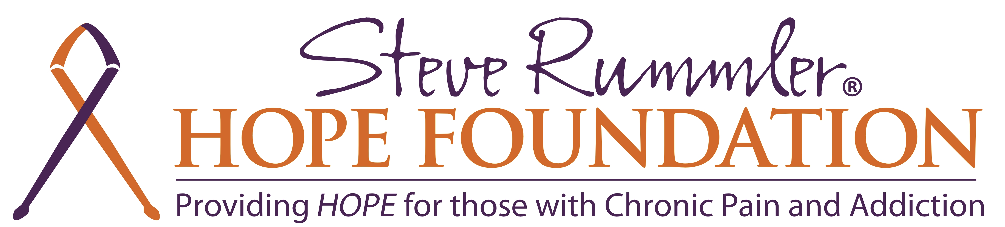

Facts in Support of Appropriations Bill SF1410 / HF1651

The Opiate Crisis in Minnesota
Opiate-related deaths from 2000-2013 increased by 222% in Hennepin County and 118% in Ramsey County. Killing 169 residents of Hennepin and Ramsey Counties in 2013.

People in rural counties in the US are nearly twice as likely to overdose on prescription painkillers as people in big cities.

Minnesota admissions to addiction treatment programs for heroin and other opiates reached 10,000 in 2013. Anecdotal reports indicate that most of the young patients entering treatment programs initially used prescription opiates before progressing to heroin addiction.

In the month of March 2014 alone, nearly 210,000 prescriptions for opioids were dispensed in
Minnesota. This represented 42% of all prescriptions filled that month. Hydrocodone and oxycodone prescriptions were by a wide margin the two most-prescribed pills in the state that month.

Prescribers wrote 61.6 opioid prescriptions per 100 persons in Minnesota during 2012.

We will see benefits in Minnesota when we invest in implementing Steve’s Law.
What we know is:
- Attorney General Holder stated that Naloxone used in concert with 911 Good Samaritan laws have resulted in the reversal of over 10,000 overdoses since 2010
- An economic analysis published in the Annals of Internal Medicine found the economic benefit in terms of life years and productivity saved versus the cost of naloxone distribution is greater than the benefits seen by mammography screening for breast cancer
- Police in Quincy, MA, Los Angeles, CA, Seattle, WA and New York state have found access to naloxone to be empowering in terms of increasing their ability to save lives
National organizations supporting 911 Good Samaritan and Naloxone Implementation:
- White House Office of National Drug Control Policy
- US Department of Health and Human Services
- US Conference of Mayors
- American Medical Association
- American Society of Addiction Medicine
- National Association of Drug Diversion Investigators
- Attorney General Holder, Justice Department
Sources:
Drug Abuse Trends in the Minneapolis/St. Paul Metropolitan Area. Carol Falkowski, Drug Abuse Dialogues
DEPARTMENT OF HEALTH AND HUMAN SERVICES, Substance Abuse and Mental Health Services
Administration. Treatment Episode Data Sets (TEDS)
CDC, MMWR, July 1, 2014

For more information contact Lexi Reed Holtum @ 651-308-8122 or lexi@steverummlerhopefoundation.org

