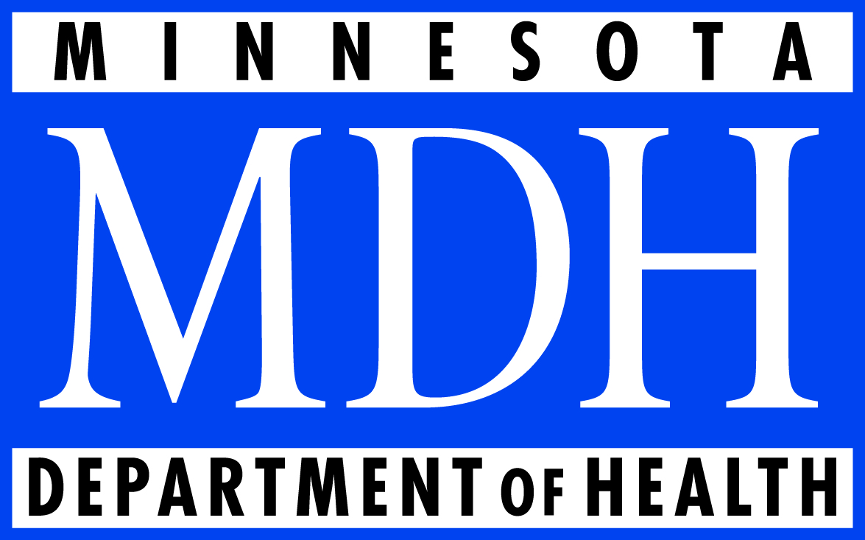Office or Rural Health and Primary CAre

P.O. Box 64882

St. Paul, MN 55164-0882

651-201-3838

www.health.state.mn.us/orhpc

# Loan Forgiveness for Dental Therapy

**Access to Dental Services**

In Minnesota, one third of dentists either will not treat Medicaid patients, or are not accepting new patients. Roughly 75% of dentists are enrolled in Medicaid, but more than one third treat fewer than 20 Medicaid enrollees per year.

Accessing dental services in rural Minnesota is a more considerable challenge – especially for Medicaid enrollees. 59 counties in Minnesota are designated as a Health Professional Shortage Area (HPSA) for dental services, meaning there is less than one dentist per 4000 residents. Waiting lists of up to a year are common.



**The Dental Therapy Profession**

Dental therapists and advanced dental therapists are a relatively new, “mid-level” practitioner in a dental clinic, akin to nurse practitioners in medical settings. They practice under a collaborative agreement with a dentist, and add flexibility and expertise to the dental team.

Minnesota law (M.S. 150A.105-106) defines specific educational, examination and practice requirements for licensed dental therapists and advanced dental therapists (see table on page 2). One of the most distinctive provisions in the statute stipulates that dental therapists practice in settings serving primarily low-income, uninsured and underserved patients, or in areas designated as HPSAs for dental care.

**Workforce, Pipeline, and Average Debt**

As of October, 2014, there were 43 licensed dental therapists in the state, 6 of which are certified advanced dental therapists. There are currently about 30 additional students who will graduate in the coming years.

Dental therapists and advanced dental therapists graduate with, on average, $70,000 in debt. Given the populations they are committed to serve, given the low rates of reimbursement in Medicaid, and given the critical need for dental services in rural Minnesota, it is important to create meaningful incentives for graduates who are considering practicing in rural areas.

Under the formula defined by the Loan Forgiveness Statute, selected participants would be eligible for an award of up to $10,500 per year for up to 4 years, to pay towards their student debt.

Table 1. Minnesota requirements for dental therapists

|  | **Educational/**  **credential requirements** | **Scope of practice** | **Level of supervision** |
| --- | --- | --- | --- |
| *Dental therapist* | * Bachelor’s degree in dental therapy. * Competency and licensure exam. * Jurisprudence examination. | A licensed dental therapist may perform certain dental services under “indirect supervision.” See Appendix B for a full list of these services.  A dental therapist may perform additional services under “general supervision” unless restricted or prohibited from doing so in the collaborative management agreement. See Appendix B for a full list of these services.  A dental therapist may also dispense certain medications and supervise up to 4 dental assistants. | Practices under the supervision of a dentist, with whom they must have a collaborative management agreement. Some dental therapy services can be provided under “indirect supervision” (the dentist is on-site and authorizes procedures) and others under “general supervision” (the dentist is not necessarily on-site during procedure but does authorize its performance). |
| *Advanced dental therapist* | * Dental therapist license. * Master’s degree in advanced dental therapy. * 2,000 hours of clinical practice. * Certification exam for advanced practice. | An advanced dental therapist certified by the Board of Dentistry may perform the following services and procedures, pursuant to a written collaborative management agreement (and any limitations therein):   * All services a dental therapist provides (see above). * Oral evaluation and assessment. * Treatment plan formulation. * Routine, nonsurgical extractions of certain diseased teeth. | Like a dental therapist, the advanced dental therapist practices under the supervision of a dentist, with whom they must have a collaborative management agreement, but all advanced dental therapy services can be provided under “general supervision.” The dentist does not need to see the patient first or be on-site during procedure. |

S:\ORHPC\Communications\Graphics\ORHPC logos for print\tif (high res) for print\ORHPC_4c.tif

For more information, contact:

Mark Schoenbaum, Director

Mark.schoenbaum@state.mn.us

(651) 201-3859