March 12, 2018
Madam Chair and Members of the Committee;
I am Jackie Harrington, a 19 year licensed family childcare provider from Rochester MN. I am writing to oppose the changes in HF 3403 as noted below.
a license holder may place the infant who has not yet begun to roll over on its own down to sleep in a one-piece sleeper equipped with an attached system that fastens securely only across the upper torso, sleep system that is not under a recall or warning from the United States Consumer Product Safety Commission with no constriction of the hips or legs, to create a swaddle.
These changes opens the door for use of many sleep systems that are not (yet) recalled or under a warning form the United States Consumer Product Safety Commission and are contrary to the Safe Sleep training we receive annually.
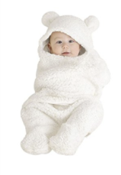
We learn that babies sleep best in room temparatures of 68 degrees, and to be careful that infants are not overdressed as overheating is a risk factor for SUIDS. This cozy suit is meant for additional warmth, potentially overheating the child, and has an attached hood which when the infant turns the head could lead to rebreathing air.

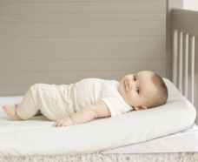
In this photo is a wedge sleep system. Our training teaches that wedges increase the risk for infants sliding into the mesh siding of pack’n plays or cribs frames where the can become trapped, again placing the infant at risk.

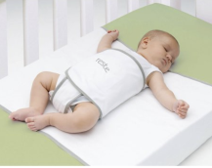
This sleep system secures the child into this sleep position. The infant is restrained and has no freedom to move out of this position. The infant should not be denied the right to change their body position.

There are many other products that can be found through a quick google search that raise other concerns and could potentially put the health and safety of infants at risk.
The language in the current law aligns with recommendations for safe sleep and should remain.
Pleases oppose this change that will place infants at risk.
Sincerely,
Jackie Harrington
Harrington.jackie.ffy@gmail.com
Rochester MN

Thank you for your consideration,

